**Fuel Price Differentials and Car Ownership: A spatial analysis of diesel cars in Northern Ireland**

**Craig Morton A\***

**Robin Lovelace B**

**Ian Philips B**

**Jillian Anable B**

A Transport Studies Group, Loughborough University, Loughborough, LE11 3TU, United Kingdom

B Institute for Transport Studies, University of Leeds, Leeds, LS2 9JT, United Kingdom

*: correspondence author – [c.morton@live.co.uk](mailto:c.morton@live.co.uk)

**Abstract**

This paper investigates whether the availability of relatively cheap diesel fuel in the Republic of Ireland affected the rate of diesel car ownership in Northern Ireland. A geographic approach is used, which involves generating spatial variables measuring nearness to the Republic of Ireland at a high geographic resolution, and comparing these with the proportion of the local car stock that is fuelled by diesel. A series of spatial regression models are specified to determine if this association between nearness to the Republic and diesel ownership persists after accounting for the effect of socioeconomic, travel, and household characteristics. The results of the analysis show that network distance to the closest fuel station in the Republic of Ireland is negatively associated with diesel car ownership in Northern Ireland. This supports the hypothesis that the availability of cheaper fuel in the Republic of Ireland is not only generating fuel-tourism, but is also affecting the structure of the car fleet registered in Northern Ireland. The findings are relevant beyond the case study and imply that the structure of a country’s car fleet is not only dependent on domestic policies, but is also affected by the policies of neighbouring countries.

1. **Introduction**

Since the end of the twentieth century, the European car fleet has undergone a process of dieselisation, whereby diesel engines have progressed from existing in a market niche to having parity with petrol engines (*1*). This transition was motivated by a host of factors including the ability of diesel engines to offer reduced carbon dioxide emission factors and increased fuel economy compared to petrol engines as well as a desire to establish a larger market for diesel fuels. Recently, the popularity of diesel engines has come under scrutiny, due in part to increased concerns regarding air quality levels and the disparity between official emission factors for local air pollutants generated by diesel engines and those observed during real-world driving conditions (*2*). This situation has led to certain urban areas proposing bans on the use of diesel cars and calls for the shift away from diesel engines throughout the car fleet.

Such a shift could be facilitated by a set of government policies which push drivers away from diesel cars (e.g. the introduction of Clean Air Zones and surcharges on diesel fuel tax) and pull drivers towards low emission vehicles (e.g. vehicle scrappage schemes and purchase incentives) (*3*). The efficacy of these strategic activities is contingent on the ability of the government to exert control over the structure of the car stock. However, there are situations where the sovereignty of this control is diminished due to the policies being deployed by exogenous agents that also affect the structure of the car stock. A version of such a situation is where the domestic policy of one nation extends into another, which may generate effects that are not aligned to the priorities of the host nation.

This paper presents a case study of such a situation by examining how fiscal measures enacted in the Republic of Ireland may have affected the structure of the car fleet in Northern Ireland. Historically, the fuel tax on road diesel in the Republic has been lower than that in effect in Northern Ireland, which has led to diesel in the Republic having been as much as 30 pence (0.3 GBP) per litre cheaper since 2000. This price differential represents a spatial arbitrage opportunity, where drivers in one area (i.e. Northern Ireland) can derive an advantage (i.e. lowering their costs) from purchasing a commodity in a nearby area (i.e. the Republic). The specific hypothesis examined in this research is that the effect of this price differential in diesel fuel diminishes as distance the Republic increases (i.e. a distance decay effect). This is pursued through a spatial analysis of the car fleet registered in Northern Ireland which focuses on the proportion of diesel cars present in local car stocks.

1. **Background**

**2.1 Spatial Arbitrage**

Countries often employ fiscal measures to manage the demand for a good and raise taxation revenue from its sale. In certain situations, neighbouring countries may follow different fiscal strategies, which leads to disparities in the sale price faced by consumers in the different countries. If the good in question is homogenous (i.e. its qualities does not differ between countries), this could generate a spatial arbitrage opportunity. Under such an opportunity, consumers of a good in a nation which has a higher sales price may reduce the costs they face by travelling to the neighbouring country where the sales price is lower to make their purchase. Spatial arbitrage opportunities have been extensively evaluate for such goods as tobacco and alcohol (*4*). The phenomenon also extends to the transport sector, where the price of fuel faced by consumers in neighbouring countries can be sufficiently different to induce what is often referred to as fuel-tourism behaviour (*5*). Such behaviour can generate a number of adverse consequences, leading to reductions in tax and fuel station revenue in the country with the higher price level as well as increasing car travel.

In an initial empirical investigation of fuel-tourism, Rietveld et al. (*6*) examined the consequences of cheaper fuel being available across the border in Germany and Belgium on the sale of gasoline in the Netherlands. Their findings indicate that the average Netherlands driver is willing to travel 1 km to a cheaper fuel station for every 1 cent difference in the price of fuel. From this finding, Rietveld et al. (*6*) recommend that the Netherlands should introduce graduated fiscal measures, whereby the tax rate applied to fuel diminishes as nearness to the border increases. The reverse situation was in effect during the latter part of the twentieth century in Switzerland, whereby the Swiss price of gasoline was substantially lower than in the neighbouring countries of France, Italy, and Germany. Banfi et al. (*7*) examined whether this price differential motivated fuel-tourism into Switzerland between 1985 and 1997 though an econometric assessment of gasoline sales within a 5 kilometre vicinity of the border. Their assessment indicates that changes to the Swiss price of gasoline, the neighbouring country price of gasoline, Swiss income per capita, and neighbouring country income per capita all affect the quantity of gasoline sold. Through a counter-factual simulation of a scenario where the fuel price differential between Switzerland and neighbouring countries did not exist, Banfi et al. (*7*) estimated that 9% of gasoline sales in the Swiss border region can be attributed to fuel-tourism during the study period.

While disparities in fuel prices are often visible between different countries, there are also examples where they exist between regions of the same country. A case in point is Spain, which since 2002 has operated a Hydrocarbons Retail Sales Tax that allows the autonomous communities of Spain to apply a regionally specific levy on fuel sales. This ability has contributed to the price of diesel varying between the autonomous communities by up to 3.4 cents per litre. Leal et al. (*8*) evaluated whether this situation affected demand for diesel in Aragon (one of the communities with the lowest diesel price) between 2001 and 2007 and found that an increase in the price of diesel in Catalonia (a neighbouring community to Aragon) increased the demand for diesel in Aragon by 1.6%. Romero-Jordán et al. (*9*) considered if the occurrence of this regional fuel levy affected the price setting behaviour of fuel stations in the vicinity of the border between regions with alternative levies. Their analysis indicates that fuel stations on the side of the border with the higher level set a lower price for diesel compared to that inland, implying that they do not fully pass the fuel levy onto customers in order to discourage fuel-tourism.

**2.2 Dieselisation**

**2.3 The Situation in Northern Ireland**

Northern Ireland represents the only nation of the United Kingdom (UK) that has a land border with another country, being the Republic of Ireland to the south and west. Since 1923, a Common Travel Area has been in effect between the United Kingdom and the Republic, following an open border policy subject to minimal control which allows for the unrestricted movement of individuals between the two countries. The fiscal measures on transport fuel in effect in Northern Ireland follow the policy set out by the UK Government. At the time of writing, this covers the application of a set fuel duty of 57.95 pence per litre for diesel as well as a 20% value added tax to the sale price. A different set of fiscal measures is in effect in the Republic which has a fuel duty of 42.57 cents per litre, a carbon tax of 5.33 cents per litre, and a 23% value added tax on the sale price.

Due to the divergent fiscal measures in effect between Northern Ireland and the Republic, a substantial price difference is apparent. Figure 1 displays the average diesel fuel price between 2000 and 2016 for Northern Ireland and the Republic, with the price difference persevering throughout this time period. At its most divergent (in 2002), the differential in fuel price between the two countries was 31 pence per litre, with an average difference of 20 pence per litre. Due to the persistence of this price differential, the possibility exists for it not only to have generated fuel-tourism but to also have motivated a higher rate of diesel car ownership in Northern Ireland due to the availability of cheaper fuel across the border.

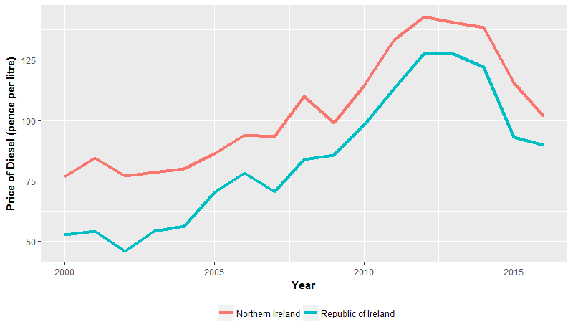

**Figure 1:** Average price of diesel road transport fuel in Northern Ireland and the Republic of Ireland (*10*)

In parallel to the fuel price difference between Northern Ireland and the Republic, another set of issues are at play that could be affecting the rate of diesel car ownership. The smuggling of cheaper fuel from the Republic into Northern Ireland by organised crime is a known issue (*11*). In addition, fuel laundering operations, which take rebated diesel (i.e. diesel sold for use off-road and not subjected to fuel duty, referred to as ‘red diesel’ in the UK) and remove the marker dyes, have a relatively high occurrence in Northern Ireland. These two issues lead to a situation whereby around 12% of the diesel sold for road transport in Northern Ireland is estimated to be illicit (*11*). It is plausible that these two issues will be concentrated in the border region due to the proximity to cheaper fuel and the relatively high level of rurality.

**Car Fleet Composition**

The structure of a local car fleet is likely to be contingent on a number of situational factors that make the ownership and use of certain types of car more or less suitable. These situation factors cover such issues as the socioeconomic characteristics of the resident population, the features of the transport system, and the presence of policies designed to promote or hinder particular car types. At a general level, the rate of car ownership and its association with household income has been examined (Clark, 2007; Clark and Finley, 2010), with substantial differences in income elasticity levels across regions found to be present, indicating that a link between car ownership and income is spatial non-stationary. Changes in the rate of car ownership in particular areas have also been found to be moderated by the rate of ownership observed in neighbouring areas (Clark and Rey, 2017), indicating that transitions between levels of ownership are effected by wider environmental contexts.

Recently, research has expanded into investigating the geographical variation in the different types of car that are owned. Car body type (e.g. salon, hatchback, and sports) represents a visibly distinctive characteristic of the local vehicle fleet, with certain chassis designed with particular environments in mind. Adjemain et al. (2010) examined the occurrence of car body types across census tracts of California and found that such factors as income level, education level, age profile, ethnic makeup, and marriage status of the population are useful in explaining the presence of certain car variations. Moreover, their analysis demonstrates that ownership rates of pickup trucks, station wagons, and sports utility vehicles tend to be spatially dependent, whereby the rates in one area are connected with the rates displayed in neighbouring areas. This spatial dependence could be generated by social conformity, by which preferences for car body type are informed by the popularity of body types in the wider region. This premise is supported by the work of Lansley (2016), whose examination of car body type across the neighbourhoods of the UK found that certain types of vehicle were connected with particular socioeconomic classes, such as the rate of luxury car ownership being associated with the rate of the population in managerial or professional employment.

The prevalence of different powertrains within local fleets has also been investigated to determine what conditions are linked to registrations of alternatively fuelled cars. The rate of Hybrid Electric Vehicles (HEVs) (Dimatulac and Maoh, 2017; Liu et al. 2017) has been found to be associated with the education and income levels of the population as well as car availability levels, commuting distances, and household size. In terms of the presence of local supporting policies, the exemption of HEVs from the London Congestion Charge has been found to represent a salient issue in consumer’s decisions to purchase a HEV (Ozaki and Sevastyanova, 2011), with Morton et al. (2017) finding that the rate of HEV ownership tends to increase as the rate of commuting by car to the London Congestion Charge increases. Similar assessments have been conducted on the exemption of natural gas vehicles from the Stockholm Congestion Charge, where Mannberg et al. (2014) applied a difference-in-difference assessment across Stockholm and Gothenburg (used as the control site) and identified a 1.2% increase in registrations of natural gas vehicles in Stockholm attributable to the exemption. Providing further evidence of this effect, Whitehead et al. (2014) developed a vehicle choice model for car registrations in Stockholm and simulated a scenario omitting the presence of the natural gas vehicle exemption, with the policy estimated to have increased the registration rates of these vehicles by 1.8%. These studies endorse the view that proximity or nearness to a policy which benefits one particular car variant (such as a certain powertrain) can encourage the registrations of such vehicles in surrounding areas. The research reported in this paper examines if such an effect is present in terms of fuel tourism between Northern Ireland and the Republic by evaluating whether the availability of cheaper diesel fuel in the Republic is promoting registrations of these vehicles in Northern Ireland.

1. **Methods**

**3.1 Sources of Data**

The dataset analysed in this paper has been assembled from a two public records. First, the Department for Transport’s (*12*) Vehicle Licensing Database represents the source of the vehicle stock data, noting the number of cars registered to private households across Northern Ireland by fuel type. The number of cars registered to corporations has been excluded from the assessment, thus the presence of company fleets should not unduly distort the results of the analysis. Second, the Northern Ireland Population Census (*13*) represents the source of the socioeconomic, household, and transport system data. The variables incorporated into the dataset are described in Table 1.

|  |  |  |  |  |
| --- | --- | --- | --- | --- |
| **Table 1:** Descriptive statistics of the dataset used in the analysis | | | | |
|  | **Min.** | **Max.** | **Mean** | **Std. Dev.** |
| *Variable of Interest* |  |  |  |  |
| Diesel Cars (%) | 22.003 | 88.089 | 49.927 | 15.619 |
| *Socioeconomics* |  |  |  |  |
| Mean Age (years) | 22.700 | 50.700 | 37.836 | 3.901 |
| Self Employed (%) | 0.905 | 20.055 | 8.587 | 4.319 |
| Level 4 Qualification – University Degree (%) | 4.307 | 63.898 | 23.336 | 9.643 |
| *Travel* |  |  |  |  |
| One Car Household (%) | 20.593 | 64.194 | 41.344 | 6.380 |
| Car Driver to Work (%) | 18.080 | 74.300 | 56.131 | 10.766 |
| Over 30 km to Work (%) | 0.445 | 28.760 | 8.284 | 5.948 |
| *Household* |  |  |  |  |
| Population Density (per hectare) | 0.100 | 143.900 | 21.397 | 24.572 |
| Mean Household Residents | 1.787 | 3.466 | 2.559 | 0.325 |
| Rent Household Socially (%) | 0.000 | 67.705 | 14.652 | 14.324 |
| Flats (%) | 0.000 | 78.025 | 8.335 | 9.806 |

**3.2 Spatial Resolution**

The variables incorporated in the dataset have been aggregated at the Super Output Area (SOA) level of administrative geography. This covers 890 contiguous spatial units which contain a mean of 2,000 individuals.

**3.3 Measurement of Nearness**

Estimating how close a spatial unit is to the Republic represents an issue of central importance. A set of different methods have been followed in order to approach the issue from multiple directions. Each of the methods is employed in the analysis to consider if the association between nearness to the Republic and the ownership of diesel cars persists across different estimation procedures.

*3.3.1 Contiguity Method*

A set of distance based buffers from the border with the Republic are set. These buffers incorporate spatial units that intersect a 5 kilometre (n = 104), 10 kilometre (n = 45), 15 kilometre (n = 31), and 20 kilometre (n = 36) buffer to the border as well as those which comprise the remainder of Northern Ireland (n = 674). This arrangement is illustrated in Figure 2a. The hypothesis here is that spatial units that have closer contiguity to the border with the Republic will tend to have higher rates of diesel car ownership.

*3.3.2 Proximity Method*

The centroid of each spatial unit is extracted and the position of each road crossing between Northern Ireland and the Republic is mapped. The Euclidean distance in kilometres between each centroid and the closest road crossing is calculated. The hypothesis here is that as the Euclidean distance to the closest road crossing increases, the rate of diesel car ownership will tend to decrease.

*3.3.3 Network Distance Method*

The centroid of each spatial unit is extracted and the location of the closest fuel station in the Republic is mapped. The network distance in kilometres between each centroid and the closest fuel station in the Republic is calculated. This arrangement is illustrated in Figure 2b. The hypothesis here is that as network distance to the closest fuel station increases, the rate of diesel car ownership will tend to decrease.

*3.3.4 Network Time Method*

The centroid of each spatial unit is extracted and the location of the closest fuel station in the Republic is mapped. The network time to travel by car in minutes between each centroid and the closest fuel station in the Republic is estimated. The hypothesis here is that as network time to the closest fuel station increases, the rate of diesel car ownership will tend to decrease.

|  |  |
| --- | --- |
|  |  |

**Figure 2:** Maps illustrating the (a) Super Output Areas that intersect set buffers to the border with the Republic of Ireland and (b) the network distance from the Super Output Areas to fuel stations in the Republic of Ireland

**3.4 Statistical Analysis**

The assessment of the dataset progresses through a series of stages.

*3.4.1 Stage One*

First, the spatial variation in diesel car ownership is considered. A boxplot (Figure 3) is produced that displays the proportion of the local authority car fleet that are fuelled by diesel grouped across the Government Office Regions of the UK. A choropleth map (Figure 4) using equal bin counts and depicting the rate of diesel car ownership across the SOAs of Northern Ireland is produced. The degree to which the rate of diesel car ownership in Northern Ireland displays spatial dependence (i.e. non-random spatial patterning) is evaluated through a spatial autocorrelation analysis. A spatial weights matrix, which allows for the calculation of spatial lags of variables, is specified following a binary queen contiguity approach whereby spatial units are classified as neighbours if they share a line or a point border. This matrix is summarised in Equation 1 where *Wij* is the contiguity between spatial units *i* and *j*. The global spatial autocorrelation Moran’s-I (*14*) statistic is calculated to consider the degree to which the rate of diesel ownership is correlated between neighbouring spatial units over all of Northern Ireland. The Local Indicator of Spatial Association (LISA; *15*) is also calculated (Figure 5) to assess if particular regions are exhibiting similar rates of diesel car ownership, indicating the presence of hot-spots and cold-spots.

|  |  |  |
| --- | --- | --- |
|  |  | (1) |

*3.4.2 Stage Two*

Second, the association between nearness to the Republic and the proportion of the local car stock that is diesel fuelled is evaluated. A boxplot (Figure 6) of the rate of diesel car ownership across the SOAs grouped by buffer category (i.e. the contiguity method) is produced. The Kruskal-Wallis test is applied to determine if these groups of SOAs significantly differ in terms of their rate of diesel car ownership. A set of scatterplots (Figure 7) are produced which have the rate of diesel car ownership across the SOAs on the y-axis and Euclidean distance to the closest road crossing (i.e. the proximity method), network distance to the closest fuel station in the Republic (i.e. the network distance method), and network time to the closest fuel station (i.e. the network time method) on the x-axis. A Spearman’s correlation analysis is utilised to determine if these variables are significantly related to one another.

*3.4.3 Stage Three*

Third, a series of log-log regression models[1] are specified in order to explain variation in diesel car ownership across the SOAs. A set of benchmark OLS models are initially produced (Table 2) which have the following arrangements:

OLS Model 1

This base model is summarised in Equation 2 were *y* is a vector of observations of diesel car ownership, *α* is a constant parameter, *βa* is a vector of coefficients associated with the area characteristic (i.e. socioeconomic, transport, and household) independent variables, *xa* is a vector set of observations of the area characteristic independent variables, and *ɛ* is the model residual.

|  |  |
| --- | --- |
| $$y= α+β_{a}x_{a}+ ε$$ | (2) |

OLS Model 2

This expands OLS Model 1 through the inclusion of dummy variables which cover the buffer categories outlined in the contiguity method. Equation 3 summarises this model, where *βc* is a vector of coefficients associated with the dummy independent variables and *xc* is a vector set of observations of the dummy variables.

|  |  |
| --- | --- |
| $$y= α+β_{a}x_{a}+β_{c}x_{c}+ ε$$ | (3) |

OLS Model 3

This expands OLS Model 1 through the inclusion of a variable measuring the Euclidean distance from the SOA centroid to the closest road crossing which is outlined in the proximity method. Equation 4 summarises this model, where *βp* is a coefficient associated with the proximity variable and *xp* is a vector of observations of the proximity variable.

|  |  |
| --- | --- |
| $$y= α+β_{a}x_{a}+β_{p}x_{p}+ ε$$ | (4) |

OLS Model 4

This expands OLS Model 1 through the inclusion of a variable measuring the network distance from the SOA centroid to the closest fuel station in the Republic which is outlined in the network distance method. Equation 5 summarises this model, where *βd* is a coefficient associated with the network distance variable and *xd* is a vector of observations of the network distance variable.

|  |  |
| --- | --- |
| $$y= α+β_{a}x_{a}+β_{d}x_{d}+ ε$$ | (5) |

OLS Model 5

This expands OLS Model 1 through the inclusion of a variable measuring the network time from the SOA centroid to the closest fuel station in the Republic which is outlined in the network time method. Equation 6 summarises this model, where *βt* is a coefficient associated with the network time variable and *xt* is a vector of observations of the network time variable.

|  |  |
| --- | --- |
| $$y= α+β_{a}x_{a}+β_{t}x_{t}+ ε$$ | (6) |

In order to determine if the benchmark OLS models need to be extended through the integration of spatial interaction effects to account for persisting spatial autocorrelation, the robust Lagrange Multiplier diagnostics are calculated (*16*). Following this, the extension of the benchmark OLS to cover the occurrence of local spatial spillovers is conducted through the specification of the Spatial Durbin Error Model (SDEM; Table 3; *17-18*). The SDEM incorporates spatial lags of the model independent variables to allow for direct, indirect, and total effects to be estimated. The model also contains a spatial lag of the benchmark OLS model’s residual to account for spatial dependence in the variables omitted from the analysis. Equation 7 and 8 summarise the structure of the SDEM, where *Ɵ* is a vector of coefficients associated with the spatially lagged independent variables, *WX* is a vector set of observations of spatially lagged independent variables, *λ* is a coefficient associated with the spatially lagged OLS residual, and *Wu* is a vector of observations of the spatially lagged OLS residual.

|  |  |
| --- | --- |
| $$y= α+ β_{a}x_{a}+β_{d}x_{d}+ θWX + u$$ | (7) |
| $$u = λWu + ε$$ | (8) |

1. **Results**

**4.1 Spatial Variation in Diesel Ownership**

Figure 3 displays the rate of diesel car ownership across the local authorities of the UK grouped by Government Office Region. From this figure, it is apparent that the local authorities of Northern Ireland tend to contain higher proportions of diesel cars in their fleets compared to other regions. This observation indicates that a factor is active in Northern Ireland that may be encouraging the ownership of diesel cars which is not present in the rest of the UK.

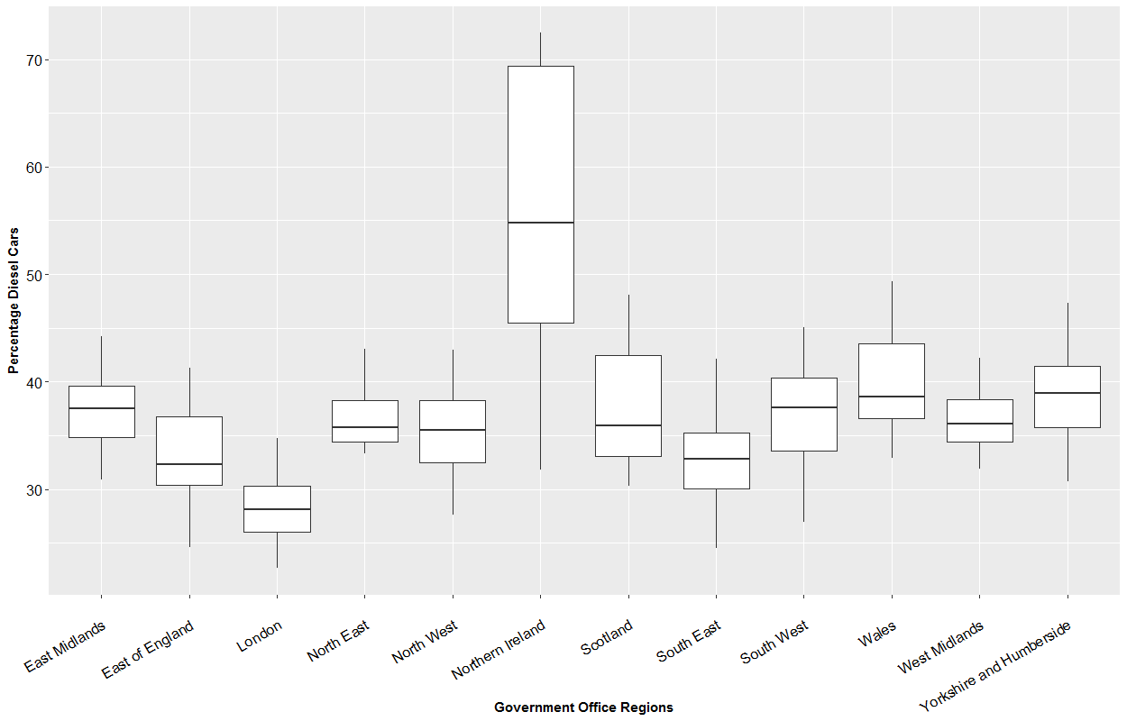

**Figure 3:** The percentage of local authority car fleets that are fuelled by diesel grouped by Government Office Region

Examining the spatial variation in diesel car ownership that is present within Northern Ireland, Figure 4 illustrates the percentage of the car fleet which is diesel fuelled across the SOAs. In this figure, it is evident that spatial units that are closer to the border with the Republic tend to display higher rates of diesel car ownership, with the rate diminishing as proximity to Belfast (the national capital located in the mid-east) increases.

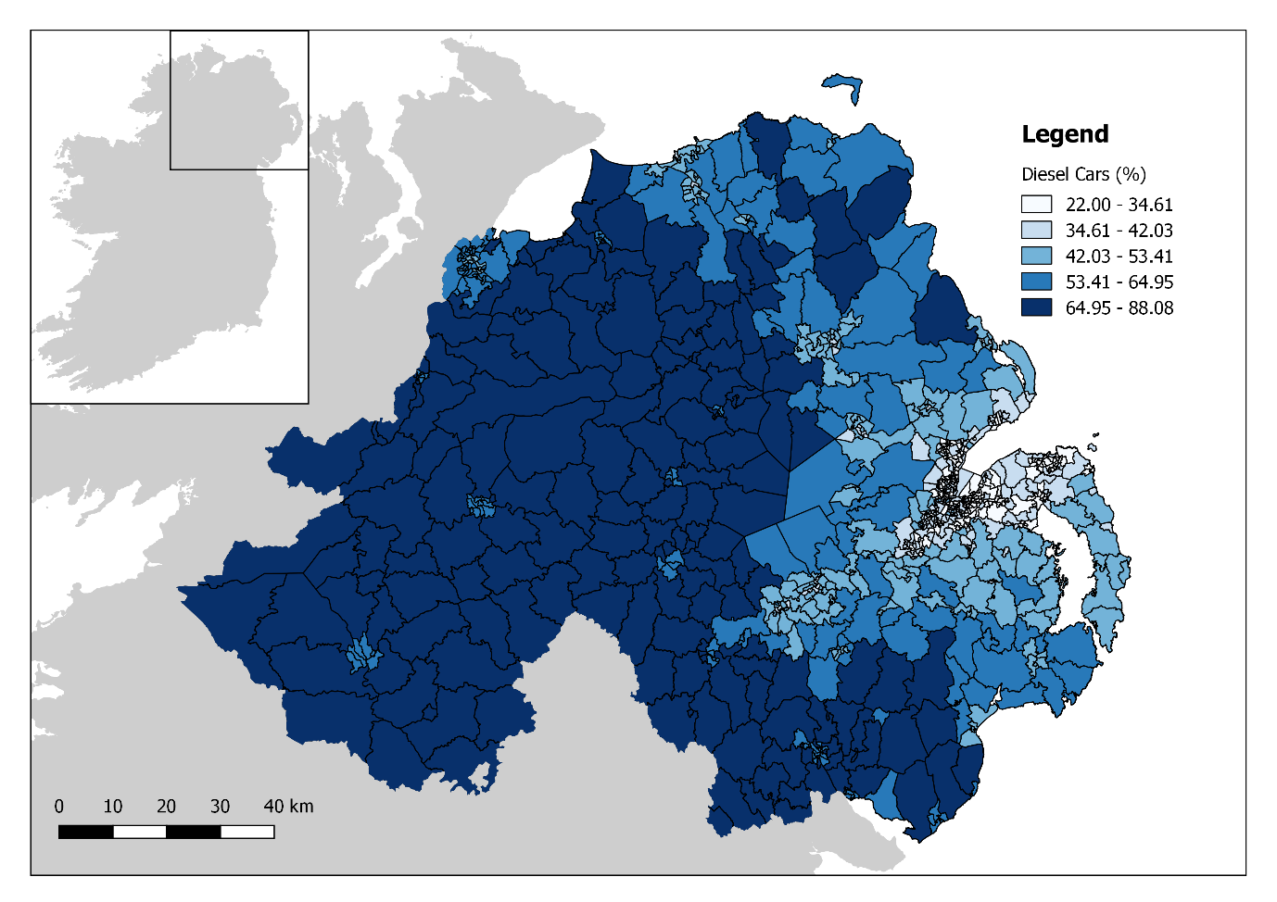

**Figure 4:** Choropleth map showing the proportion of the local car fleet that is diesel fuelled across the Super Output Areas of Northern Ireland

The spatial patterning in the rate of diesel car ownership also exhibits signs of spatial dependence, whereby the proportion of the car fleet which is diesel fuelled in one spatial unit tends to be related to the proportion observed in neighbouring spatial units. This is supported by Moran’s-I test of spatial autocorrelation, which returns a strong positive coefficient (*I* = 0.919, p-value < 0.01). The occurrence of spatial dependence is clearly visible in the LISA analysis reported in Figure 5. Here, it is apparent that the border region of Northern Ireland, and extending a considerable distance inland, represents a hot-spot of diesel car ownership. This border region is predominately rural in terms of its settlement pattern, with the city of Londonderry (located at the North-West border to the Republic) being the only major urban centre. Conversely, a cold-spot is present in the mid-east of the country and corresponds with the metropolitan area of Belfast. A number of small regions which display no significant spatial autocorrelation appear to be sporadically distributed throughout the border hot-spot. These small non-significant regions correspond to the border towns (such as Omagh, Armagh, and Enniskillen), indicating that a rural-urban divide is present in terms of the diesel car ownership.

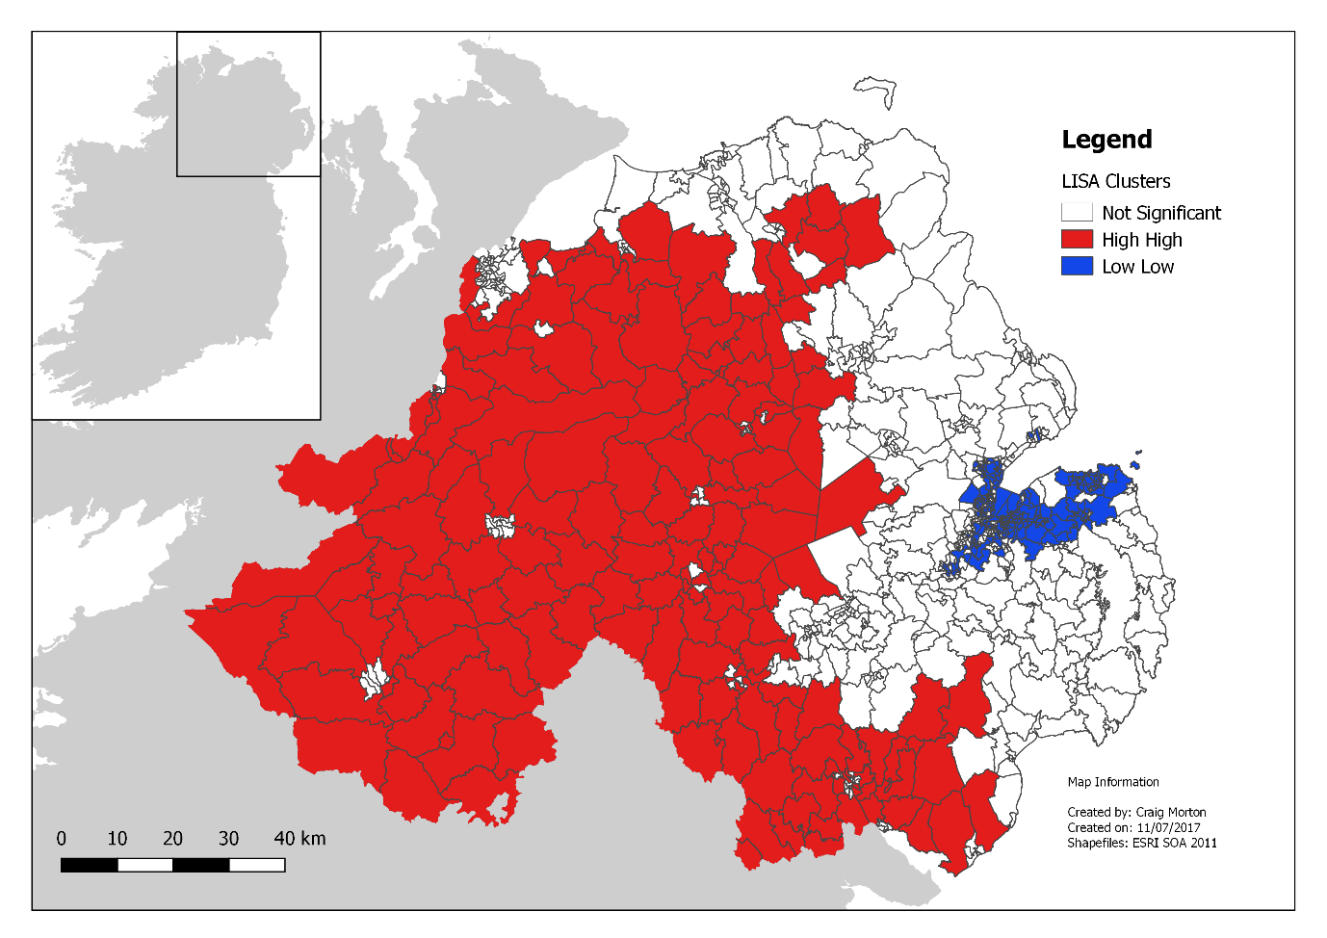

**Figure 5:** Local indicator of spatial association concerning the proportion of the local car fleet which is diesel fuelled

**Nearness to the Republic of Ireland**

Figure 6 displays the dispersion of the local car fleet that is fuelled by diesel across the border buffer groups of SOAs (i.e. the contiguity method). SOAs that intersect a 5, 10, 15, and 20 km buffer with the border to the Republic of Ireland appear to have similar rates of diesel car ownership. This rate decreases noticeably for the SOAs that are outside of a 20 km buffer to the border (i.e. the rest of Northern Ireland), where the average rate of diesel car ownership is approximately 40%. The visible difference between the SOAs of the rest of Northern Ireland category and those assigned the buffer categories is supported by a significant Kruskal-Wallis test result (H = 335.929, p-value < 0.01).

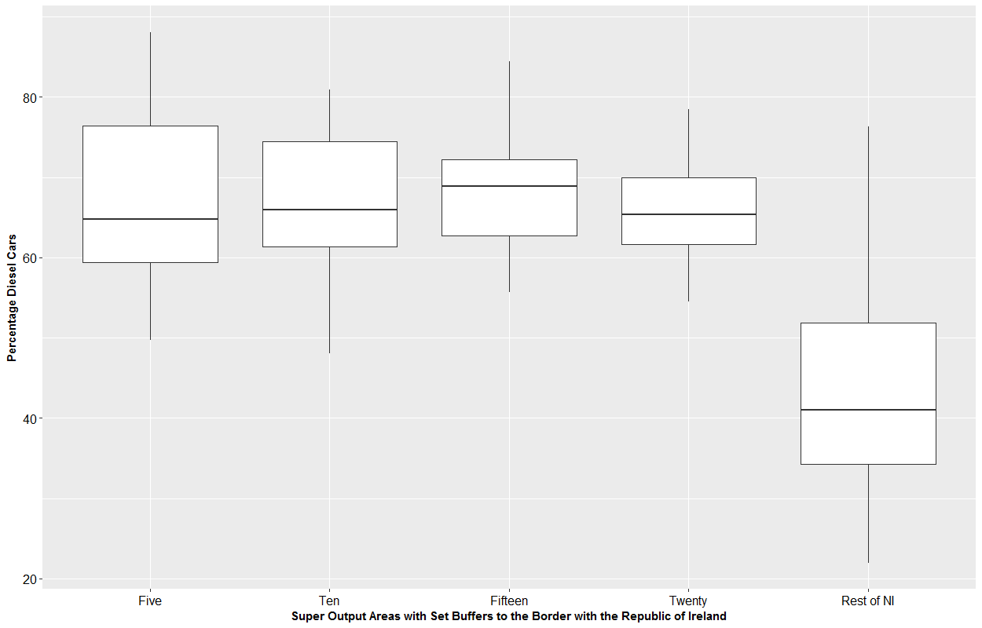

**FIGURE 6 Boxplots grouping Super Output Areas by buffer to the border with the Republic of Ireland by the proportion of the car fleet that is fuelled by diesel**

Figure 7a evaluates the relationship between diesel car ownership and Euclidean distance to the nearest road crossing into the Republic (i.e. the proximity method). In this instance, a negative relationship is evident (rs: -0.713, p-value < 0.01), implying that as proximity to the border decreases, the rate of diesel car ownership tends to decrease. A similar set of findings is presented when considering network distance to the nearest fuel station in the Republic (Figure 7b; rs: -0.598, p-value < 0.01) and network time to the nearest fuel station (Figure 7c, rs: -0.475, p-value < 0.01).

|  |  |  |
| --- | --- | --- |
|  |  |  |

**FIGURE 7 Scatterplots of proportion of the Super Output Area car fleet that is diesel fuelled (y-axis) against (a) Euclidean distance to the nearest road crossing, (b) network distance to the nearest fuel station in the Republic of Ireland, and (c) network time to the nearest fuel station in the Republic of Ireland**

**Regression Analysis**

The benchmark log-log OLS regression models, which have the proportion of the car stock which is diesel fuelled as the dependent variable, are reported in Table 2. The inclusion of measurements of nearness to the Republic (OLS Models 2 to 4) provide significant improvements to model fit as compared to the base model (OLS Model 1) which only considers the effects of socioeconomic, travel, and household characteristics. The dummy variables which cover 5km (Beta: 0.241), 10km (Beta: 0.232), 15km (Beta: 0.231), and 20km (Beta: 0.163) buffers from the border all display significant coefficients with the size of these coefficients diminishing as nearest to the Republic decreases. A similar set of findings is observed for the variables measuring the Euclidean distance to the nearest road crossing (Beta: -0.107), the network distance to the nearest fuel station in the Republic (Beta: -0.128), and the network time to the nearest fuel station (Beta: -0.135). These findings indicate that there is a persisting association between the proportion of the car fleet that is diesel fuelled and nearness to the Republic, having controlled for the effects of socioeconomic, travel, and household characteristics.

Examining the spatial diagnostics which are reported at the bottom of Table 2, the robust Lagrange Multiplier (LM) tests return significant results in all instances and indicates that an extension of the benchmark OLS which corrects for persisting spatial autocorrelation in the model error term (i.e. the SDEM) is appropriate. As the model which incorporates the measurement of network distance to the nearest fuel station in the Republic (i.e. OLS: Model 4) displays the best model fit statistics, it is selected for extension.

|  |  |  |  |  |  |
| --- | --- | --- | --- | --- | --- |
| **TABLE 2 Results of the benchmark log-log OLS regression models with the proportion of the car fleet that is diesel fuelled as the dependent variable** | | | | | |
|  | **OLS: M1** | **OLS: M2** | **OLS: M3** | **OLS: M4** | **OLS: M5** |
|  | Beta  (St. Err.) | Beta  (St. Err.) | Beta  (St. Err.) | Beta  (St. Err.) | Beta  (St. Err.) |
| Intercept | 4.293**  (0.342) | 4.580**  (0.275) | 6.007**  (0.276) | 6.277**  (0.277) | 5.259**  (0.272) |
| *Socioeconomics* |  |  |  |  |  |
| Mean Age | -0.147*  (0.072) | -0.172**  (0.058) | -0.180**  (0.056) | -0.187**  (0.056) | -0.170**  (0.057) |
| Self Employed | 0.047  (0.024) | 0.054**  (0.020) | 0.070**  (0.019) | 0.085**  (0.019) | 0.081**  (0.019) |
| University Degree | -0.094**  (0.019) | -0.087**  (0.015) | -0.101**  (0.015) | -0.116**  (0.015) | -0.126**  (0.015) |
| *Travel* |  |  |  |  |  |
| One Car | -0.062  (0.039) | -0.125**  (0.032) | -0.134**  (0.031) | -0.122**  (0.030) | -0.115**  (0.031) |
| Drive Commute | -0.164**  (0.039) | -0.110**  (0.032) | -0.118**  (0.031) | -0.118**  (0.030) | -0.112**  (0.031) |
| Over 30km Commute | 0.189**  (0.008) | 0.163**  (0.006) | 0.147**  (0.006) | 0.152**  (0.006) | 0.167**  (0.006) |
| *Household* |  |  |  |  |  |
| Population Density | -0.048**  (0.006) | -0.040**  (0.005) | -0.046**  (0.004) | -0.048**  (0.004) | -0.047**  (0.004) |
| Mean Residents | 0.928**  (0.082) | 0.698**  (0.067) | 0.592**  (0.065) | 0.599**  (0.065) | 0.617**  (0.066) |
| Rent Social | 0.028**  (0.006) | 0.017**  (0.005) | 0.008  (0.005) | 0.008  (0.005) | 0.008  (0.005) |
| Flats | 0.008  (0.005) | 0.009*  (0.004) | 0.010**  (0.004) | 0.012**  (0.004) | 0.012**  (0.004) |
| *Nearness to the Republic of Ireland* | | | | | |
| 5km Buffer |  | 0.241**  (0.013) |  |  |  |
| 10km Buffer |  | 0.232**  (0.019) |  |  |  |
| 15km Buffer |  | 0.231**  (0.022) |  |  |  |
| 20km Buffer |  | 0.163**  (0.021) |  |  |  |
| Distance to Crossing |  |  | -0.107**  (0.004) |  |  |
| Network Distance to Fuel |  |  |  | -0.128**  (0.005) |  |
| Network Time to Fuel |  |  |  |  | -0.135**  (0.006) |
| *Model Fit* |  |  |  |  |  |
| R2 | 0.784 | 0.862 | 0.869 | 0.871 | 0.867 |
| Log Likelihood | 448.701 | 648.562 | 670.487 | 678.105 | 663.179 |
| AIC | -875.403 | -1267.12 | -1316.97 | -1332.21 | -1302.36 |
| *Spatial Diagnostics* |  |  |  |  |  |
| Robust LM (lag) | 17.355** | 9.132** | 5.673** | 5.549** | 5.718* |
| Robust LM (error) | 761.4268** | 501.963** | 524.648** | 514.523** | 496.497** |
| *- p-value < .05; ** - p-value < .01 | | | | | |

The results of the SDEM are reported in Table 3. In terms of the socioeconomic characteristics included in the model, the mean age of the population holds a significant direct effect (Beta: -0.154), implying that older populations are linked with petrol car ownership. The proportion of the population that is classified as self-employed also displays a significant direct effect (Beta: 0.068), suggesting that self-employed works are associated with diesel car ownership. The variable measuring the proportion of the population that holds a university degree has a significant indirect effect (Beta: -0.099), indicating that the presence of educated residents in the vicinity is related to reductions in diesel car ownership.

The travel characteristics included in the model begin with the proportion of one car households which holds a significant direct effect (Beta: -0.118), implying that areas that have high levels of single car ownership tend to have higher rates of petrol cars. The proportion of the population that drives a car to work displays a significant negative direct effect (Beta: -0.112). On the surface, this result seems counterintuitive, as car commuters are generally thought to favour the increased fuel economy that diesel cars offer. However, this issue is likely captured by the variable measuring the proportion of car commuters that travel over 30 kilometres to work, which has the expected significant positive direct (Beta: 0.059) and indirect (Beta: 0.087) effects. Thus, the negative coefficient for car commuters could be motivated by short distance car commuters that are associated with petrol cars.

The variable measuring population density holds a significant direct (Beta: -0.022) and indirect (Beta: -0.028) effect in the model, implying both density within and in the vicinity of areas affect the rate of diesel ownership. The mean number of residents per household displays a significant direct effect (Beta: 0.418), with this finding likely linked to larger households being more inclined to own larger cars which are more likely to be fuelled by diesel. The variables measuring both the proportion of households that are rented socially (e.g. from a local authority) and are classified as flats hold significant positive direct effects, through the size of their coefficients indicates that they are of secondary importance.

|  |  |  |  |
| --- | --- | --- | --- |
| **TABLE 3 Results of the Spatial Durbin Error Model with the proportion of the car fleet that is fuelled by diesel as the dependent variable** | | | |
|  | **Direct**  Beta  (Std. Err) | **Indirect**  Beta  (Std. Err) | **Total**  Beta  (Std. Err) |
| *Socioeconomics* |  |  |  |
| Mean Age | -0.154**  (0.042) | -0.071  (0.108) | -0.225  (0.130) |
| Self Employed | 0.068**  (0.014) | 0.002  (0.039) | 0.070  (0.047) |
| University Degree | 0.004  (0.013) | -0.099**  (0.031) | -0.095**  (0.035) |
| *Travel* |  |  |  |
| One Car | -0.118**  (0.024) | -0.067  (0.059) | -0.185**  (0.070) |
| Drive Commute | -0.112**  (0.028) | -0.049  (0.064) | -0.161**  (0.073) |
| Over 30km Commute | 0.059**  (0.008) | 0.087**  (0.014) | 0.146**  (0.015) |
| *Household* |  |  |  |
| Population Density | -0.022**  (0.003) | -0.028**  (0.009) | -0.050**  (0.010) |
| Mean Residents | 0.418**  (0.052) | 0.202  (0.127) | 0.620**  (0.152) |
| Rent Social | 0.008*  (0.003) | 0.005  (0.009) | 0.013  (0.011) |
| Flats | 0.007*  (0.003) | 0.006  (0.007) | 0.012  (0.008) |
| *Nearness to the Republic of Ireland* |  |  |  |
| Network Distance to Fuel Station | -0.011  (0.021) | -0.127**  (0.025) | -0.139**  (0.014) |
| *Spatial Interaction Effect* |  |  |  |
| λ | 0.781**  (0.024) |  |  |
| *Model Fit* |  |  |  |
| Log Likelihood | 1053.36 |  |  |
| AIC | -2056.7 |  |  |
| *- p-value < .05; ** - p-value < .01 | | | |

**CONCLUSIONS**

This paper investigates whether the availability of cheaper diesel fuel in the Republic of Ireland affects the level of diesel car ownership in Northern Ireland. Due to the friction of distance (i.e. the cost of driving across the border to refuel), the hypothesis is that the availability of cheaper diesel is having the most effect in locations nearest to the Republic as opposed to locations far removed from it. The spatial analysis provides evidence supporting this hypothesis, by demonstrating that network distance to fuel stations in the Republic is associated with diesel car ownership. This association remains after controlling for the effect of socioeconomic, travel, and household characteristics.

A number of important interpretations can be made from this case study. First, fiscal measures that are enacted in one country may extend their reach into another. This can have implications for the ability of a Government to manage their country’s car stock and may restrict transition strategies. For example, the authority of the UK government to discourage the ownership of diesel cars through alterations to fuel duty (i.e. raising it for diesel) could be hindered in Northern Ireland by the lower price of diesel available in the Republic. Second, the car stock of one country is not a closed system and can be subject to exogenous factors (e.g. the price of fuel available in neighbouring countries). This means that vehicle stock models which do not take account of this potential coupling between countries are likely to produce biased forecasts. For instance, if the vehicle stock of Northern Ireland was to be simulated into the future without accounting for the effect of the Republic’s fiscal measures, it is likely that the scenarios produced would be inaccurate.

**REFERENCES**

1. Schipper, L., and Fulton, L. Dazzled by diesel? The impact on carbon dioxide emissions of the shift to diesels in Europe through 2009. Energy Policy, 54, 2013, 3–10. https://doi.org/10.1016/j.enpol.2012.11.013
2. Brand, C. Beyond “Dieselgate”: Implications of unaccounted and future air pollutant emissions and energy use for cars in the United Kingdom. Energy Policy, 97, 2016, 1–12. https://doi.org/10.1016/j.enpol.2016.06.036
3. Brand, C., Anable, J., & Tran, M. Accelerating the transformation to a low carbon passenger transport system: The role of car purchase taxes, feebates, road taxes and scrappage incentives in the UK. Transportation Research Part A: Policy and Practice, 49, 2013, 132–148. https://doi.org/10.1016/j.tra.2013.01.010
4. Leal, A., López-Laborda, J., and Rodrigo, F. Cross-Border Shopping: A Survey. *International Advances in Economic Research*, *16*(2), 2010, 135–148. https://doi.org/[10.1007/s11294-010-9258-z](http://dx.doi.org/10.1007/s11294-010-9258-z)
5. Rietveld, P., and van Woudenberg, S. Why fuel prices differ. *Energy Economics*, *27*(1), 2005, 79–92. https://doi.org/[10.1016/j.eneco.2004.10.002](http://dx.doi.org/10.1016/j.eneco.2004.10.002)
6. Rietveld, P., Bruinsma, F. R., and van Vuuren, D. J. Spatial graduation of fuel taxes; consequences for cross-border and domestic fuelling. *Transportation Research Part A: Policy and Practice*, *35*(5), 2001, 433–457. https://doi.org/[10.1016/S0965-8564(00)00002-1](http://dx.doi.org/10.1016/S0965-8564(00)00002-1)
7. Banfi, S., Filippini, M., and Hunt, L. C. Fuel tourism in border regions: The case of Switzerland. *Energy Economics*, *27*(5), 2005, 689–707. https://doi.org/[10.1016/j.eneco.2005.04.006](http://dx.doi.org/10.1016/j.eneco.2005.04.006)
8. Leal, A., López-Laborda, J., and Rodrigo, F. Prices, taxes and automotive fuel cross-border shopping. *Energy Economics*, *31*(2), 2009, 225–234. https://doi.org/[10.1016/j.eneco.2008.09.007](http://dx.doi.org/10.1016/j.eneco.2008.09.007)
9. Romero-Jordán, D., García-Inés, M. J., and García, S. Á. The impact of fuel tourism on retailers’ diesel price in Spanish neighbouring regions. *Applied Economics*, *45*(4), (013, 407–413. https://doi.org/[10.1080/00036846.2011.605757](http://dx.doi.org/10.1080/00036846.2011.605757)
10. Automobile Association. UK and Overviews Petrol and Diesel Prices. <http://www.theaa.com/driving-advice/driving-costs/fuel-prices>. Accessed 26 July 2017.
11. House of Commons. Fuel laundering and smuggling in Northern Ireland. <http://www.parliament.uk/business/committees/committees-a-z/commons-select/northern-ireland-affairs-committee/inquiries/parliament-2010/fuel-laundering-and-smuggling/>. Accessed 26 July 2017.
12. Department for Transport. Vehicle licensing statistics. <https://www.gov.uk/government/collections/vehicles-statistics>. Accessed 26 July 2017.
13. Northern Ireland Statistics and Research Agency. Population census of Northern Ireland. <https://www.nisra.gov.uk/statistics/2011-census/results>. Accessed 26 July 2017.
14. Moran, P. A. P. The Interpretation of Statistical Maps. *Journal of the Royal Statistical Society. Series B (Methodological)*, *10*(2), 1948, 243–251. Retrieved from <http://www.jstor.org/stable/2983777>
15. Anselin, L. Local Indicators of Spatial Association—LISA. *Geographical Analysis*, *27*(2), 1995, 93–115. https://doi.org/[10.1111/j.1538-4632.1995.tb00338.x](http://dx.doi.org/10.1111/j.1538-4632.1995.tb00338.x)
16. Anselin, L., Bera, A. K., Florax, R., and Yoon, M. J. Simple diagnostic tests for spatial dependence. *Regional Science and Urban Economics*, *26*(1), 1996, 77–104. https://doi.org/[10.1016/0166-0462(95)02111-6](http://dx.doi.org/10.1016/0166-0462(95)02111-6)
17. LeSage, J., and Pace, R. K. *Introduction to Spatial Econometrics*. Boca Raton: Chapman and Hall/CRC, 2009.
18. Elhorst, J. P. *Spatial Econometrics: From Cross-Sectional Data to Spatial Panels*. New York: Springer, 2014.

1. For two independent variables measuring percentage of the housing stock that is [1] flats and [2] socially rented, one spatial unit in each instance had a zero observation. To allow for the calculation of natural logarithms, a small constant (0.01) was added to these variables